**Moving towards being trauma-informed and trauma-responsive**

**Summary:**

This day workshop is an opportunity to learn further about what is a trauma-informed and trauma-responsive organisation; and to meaningfully reflect as to why a trauma- informed and trauma-responsive organisation is needed, is important, and is beneficial to everyone. This workshop supports attendees to reflect, notice, magnify, and celebrate what they are already doing that is going well, and which is in line with the principles of trauma-informed practice. As well as making action plans and commitments for what areas need improvement, and expansion. This day presents a variety of best practice trauma-informed and trauma-responsive models; as well as giving tangible examples and case studies. This includes considering areas across the whole organisation such as recruitment and induction, through to behaviour policies, through to the physical environment, through to self-care, and so forth.

**Learning methods:**

The day will utilise an array of learning and teaching styles including small group discussions, experiential hands-on learning, multimedia methods, and lecture delivery. Case studies and live examples will be interwoven throughout. Handouts and additional learning resources will be provided.

**Aims and objectives of the day:**

* Learn about what being trauma-informed and trauma-responsive means and looks like; and establish why it is needed, important, and beneficial.
* Learn about several best practice models for being trauma-informed and trauma-responsive.
* Increase knowledge and understanding around specific components of practice being more trauma-informed such as induction and recruitment, through to the physical environment, through to “service user” involvement, through to behaviour responses.
* Reflect on what is going well already and how can this be magnified, strengthened, and celebrated.
* Develop action plans, momentum, and ideas from the group as to ways to become more trauma-informed and trauma-responsive.

**About the Presenter:**

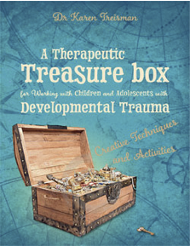  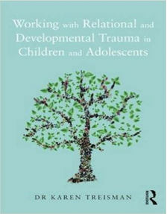

Dr Karen Treisman is a Highly Specialist Clinical Psychologist who has worked in the NHS and children’s services for several years. Karen has also worked cross-culturally in both Africa and Asia with groups ranging from former child soldiers to survivors of the Rwandan Genocide.

Karen has extensive experience in the areas of trauma, parenting, and attachment, and works clinically using a range of therapeutic approaches with families, systems, and children in or on the edge of care, unaccompanied asylum-seeking young people, and adopted children.

In addition to holding a doctorate in Clinical psychology, Karen has undergone a range of specialist trainings including in EMDR, Narrative Therapy, Dyadic Developmental Psychotherapy, Sensory Attachment Intervention, and Theraplay.

Karen has previously worked in both Milton Keynes’s and Kensington and Chelsea’s Looked after Children (LAC) and fostering services, and within the National Implementation Service for evidence-based interventions for Looked after children, children on the edge of care, and children in custody at the Michael Rutter Centre in the Maudsley Hospital.

Karen also worked as a Clinical Lead for a court assessment and intensive parenting intervention team for children on the edge of care and in proceedings within Islington.

Karen is the director of Safe Hands and Thinking Minds training and consultancy services. www.safehandsthinkingminds.co.uk

Karen is an external consultant, trainer, and assessor to Barnardos Adoption Service, PAC-UK, Hope for families, Frontline, Three Steps Ireland, Grandparents Plus, and the Fostering Network.

Karen is a member of the CoramBAAF health group advisory committee, and a reviewer for the Journal of adoption and fostering.

Karen is a TedX speaker and regularly presents at local, national, and international trauma, parenting, and attachment conferences.

Karen has written a Routledge published book entitled "Working with children and adolescents who have experienced relational and developmental trauma"; and her second book “A therapeutic treasure box for working with relational and developmental trauma” is a bestseller. Karen is also author and creator of the